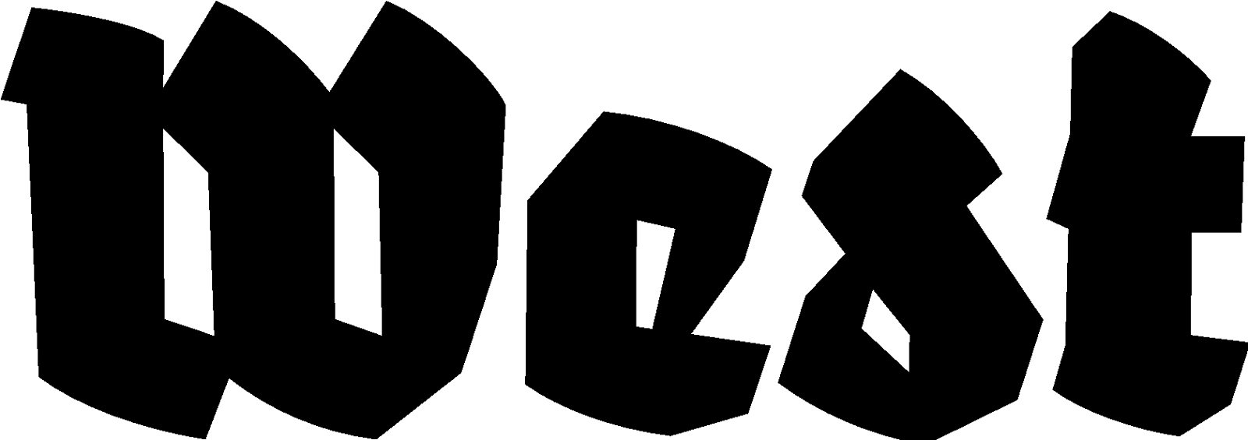

Press Announcement: 15.07.2025

Labyrinth Within
Razia Barsatie & Sarojini Lewis

Exhibition: 06.09.2025 — 07.12.2025
Opening: 06.09.2025, 19:00 hrs.
Location: West Den Haag in the former American Embassy, Lange Voorhout 102, The Hague

Labyrinth Within is a site-specific installation by Razia Barsatie and Sarojini Lewis, in which they weave their memories of Hindustani-Surinamese culture with themes such as migration, intergenerational silence, and female identity. The exhibition invites visitors into the artists’ personal labyrinth, shaped by shared heritage, histories of migration, and taboos surrounding gender, sexuality, and ancestry.

Their collaboration is rooted in a shared cultural background and a common desire to break the silences within their communities through art. By intertwining their experiences, they create a
powerful presentation that reflects on their childhoods: Lewis from a non-traditional Hindustani-Surinamese perspective, and Barsatie from her Hindustani-Surinamese background in Suriname. In the former offices of the American Embassy, they present video works, archival photographs, sculptures, and texts.

The exhibition’s title refers to the inner maze that emerges when cultural codes, upbringing, spirituality, and family history intermingle. Their work links personal stories to universal questions: What does it mean to grow up between two cultures as a descendant of contract labourers? How do women shape their voices within patriarchal structures? And how can we break the taboos of family secrets?

At the heart of the exhibition is the installation Ogri Eye, in which the evil eye — a spiritual symbol from Hindustani-Surinamese culture — serves as a metaphor for hidden memories, fears, and the longing for protection. The artworks reference domestic objects, Surinamese bus stops, and abandoned plantations, which function as carriers of collective memory.

In addition to the spatial installations, Sarojini Lewis presents a performance on the opening night, creating a direct link between art and audience. By activating the power of presence, she makes collective memory tangible.

Razia Barsatie (1982) is an artist, writer, and performer. She studied at the Nola Hatterman Art Academy in Paramaribo, the University of the Arts (HKU), and the Rijksakademie van Beeldende Kunsten in Amsterdam. Her work has been presented at the Stedelijk Museum Amsterdam, the Frankfurter Kunstverein in Germany, and Kunstinstituut Melly in Rotterdam. She participated in the Bienal de la Imagen en Movimiento (BIM) in Buenos Aires, Argentina, and recently exhibited work at Para Site in Hong Kong.

Sarojini Lewis (1984) is a visual artist and researcher. She has presented her work at the National Library of the Netherlands (KB), the Wereldmuseum Rotterdam, the Biennale für aktuelle Fotografie in Mannheim, Germany, Tropenbibliothek in Basel, Switzerland, and in the group exhibition To Be Continued at FoAM in Brussels. She has participated in residencies in Berlin and São Paulo and is actively involved in transnational collaborations on postcolonial memory and feminist narratives.
-
For more information, please contact us: info@westdenhaag.nl or +31(0)70.3925359

The program of West is made possible by the Municipality of The Hague and the Ministry of Education, Culture and Science.

