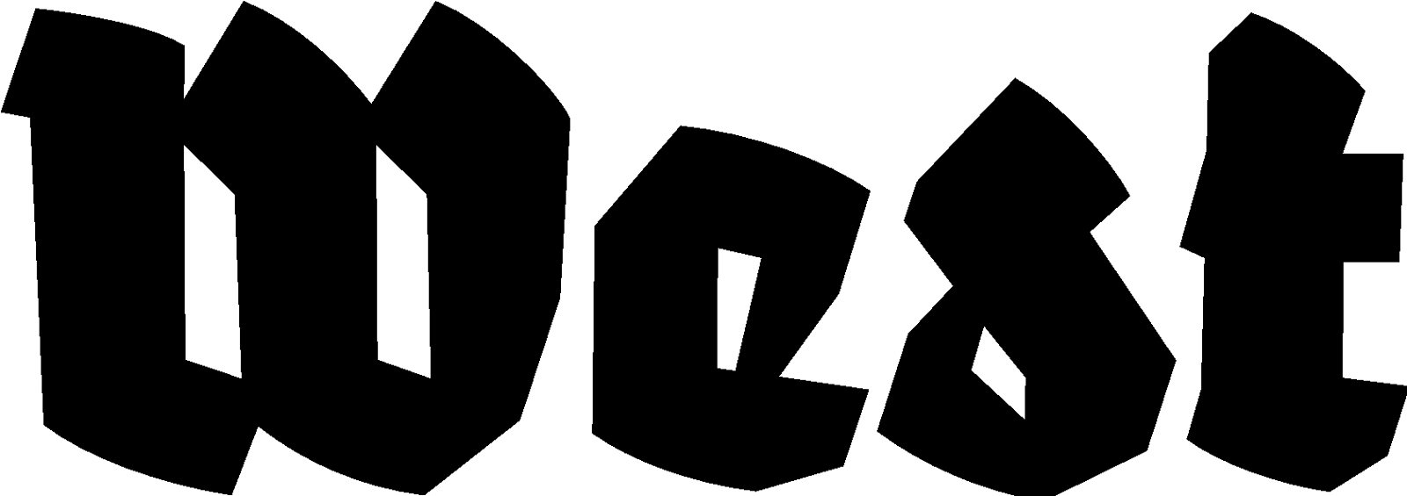

Press Release 28/07/2023

Gaps we want you to feel —
a lingering game
A.L.C. Collective

Project: 02.09.2023 - 08.10.2023
Performances: 02.09.2023, 29.09.2023, 07.09.2023 Aanvang: 19:00 hrs.
Location: West in the former American Embassy, Lange Voorhout 102, The Hague

How is normativity defined? And in which ways does it dictate our identity? Are you fitting for society? How is your life and your body a data storage? What are the abstract currencies you pay with on your daily basis?

Based on administrative processes, this performative installation offers the participants the opportunity to be confronted with the limits of their own "conformism". ‘Gaps’ allows the people that experience it the opportunity to emancipate themselves from the inevitable reification that comes out of systematic filling.
Both through interpersonal exchanges and indirect interactions, participants will have to challenge the social constructs they abide by, to break free off this Kafkaesque game-like experience. How is society’s organization there to facilitate their lives? Can they perpetuate those bureaucratic processes themselves? Relying on forms, isoloirs and waiting rooms, ‘Gaps’ will make you wander within an institutional cosmos to question our perceptions, positions, and perspectives regarding the administrative game, one we all must go through without always knowing its precise rules or purpose.

The A.L.C. collective, founded in 2022, regroups three artists: Anna Zimante, Charlotte Kremberg and L. Meïko Touraille, respectively based in the Netherlands, Germany and Switzerland. They were brought together during their exchange semester at KABK, in The Hague, and started working with the absurdity of social structures and human behaviors, trying to find their way around it from within. "We discuss, we agree and disagree, and we throw it away as an art piece, otherwise we would go crazy in this world!”

‘Gaps’ takes parts of these fields of experimentation by looking upon the human dynamics that emerge from the administrative context — how norms and codes mold social behaviors and how systematic filling ultimately leads to objectification. Thus, making collaboration between humans even more complex.

Anna Zimante is a nation-fluid active migrant multimedia artist. Born in Riga, she grew up in Lisbon and Konstanz and is currently based in The Hague and in Karlsruhe. Her artistic practice revolves around analyzing hollow spaces in communication, constraints of media language and the dimensions of the human grid.

Charlotte Kremberg was born in 1996 and grew up in Leipzig. Since 2019 she has been studying at the HBK Braunschweig in Asta Grötings class for video, performance and sculpture, and furthermore in the class for sound art. In the artistic works, the predominantly performative explorations of the body and resonance of space are in the foreground.

L. Meïko Touraille is a french artist based in the Jura. Their work focuses primarily on performance and writing, both of which explores the intricate relationship among symbolism, perception and language — be it verbal or non-verbal — as to draw up a map of human possibilities.

For questions you can contact us: press@westdenhaag.nl of 070.3925359

West's programme is facilitated by the Municipality of The Hague and the Ministry of Education, Culture and Science.

